**MODERN PUBLIC SCHOOL**

**HOLIDAY HOMEWORK**

**CLASS – VII (MATHS)**

**1) Arrange the following fractions in ascending order:**

**(i) (3/8), (5/6), (6/8), (2/4), (1/3)**

**(ii) (4/6), (3/8), (6/12), (5/16)**

**2)** Solve the following:  
(i) (-15) × 8 + (-15) × 4  
(ii) [2 × 17 + (-4)] ÷ 15

3) Solve the following equations and check the answers.  
Simple Equations Class 7 Extra Questions Maths Chapter 4 Q4

4) If 5 is added to twice a number, the result is 29. Find the number.

5) Each of the 2 equal sides of an isosceles triangle is twice as large as the third side. If the perimeter of the triangle is 30 cm, find the length of each side of the triangle.

6) Find the mean and median of first five prime numbers.

7) Find the mode of the following data:  
24, 26, 23, 26, 22, 25, 26, 28

8) Write down a pair of integers whose  
(i) sum is -5  
(ii) difference is -7  
(iii) difference is -1  
(iv) sum is 0

9) Write the following statements in the form of equations.  
(a) The sum of four times a number and 5 gives a number five times of it.  
(b) One-fourth of a number is 2 more than 5.

10) Seven times a number is 12 less than thirteen times the same number. Find the number.

11) **What number should be added to (-5/7) to get (-2/3)?**

**12)** **By what number should we multiply (-15/28) so that the product may be (-5/7)?**

**13)** The given table shows the freezing points in °F of different gases at sea level. Convert each of these into °C to the nearest integral value using the relations and complete the table  
C = 5/9 [F – 32]  
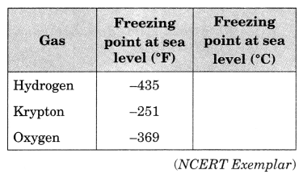

***Activity***.: Compare the population of Manipur And Haryana in the last four years by double bar graph

***Note***: 1) Do holiday homework in Maths notebook.

2) Revise ch 1, 2, 3 in rough notebook